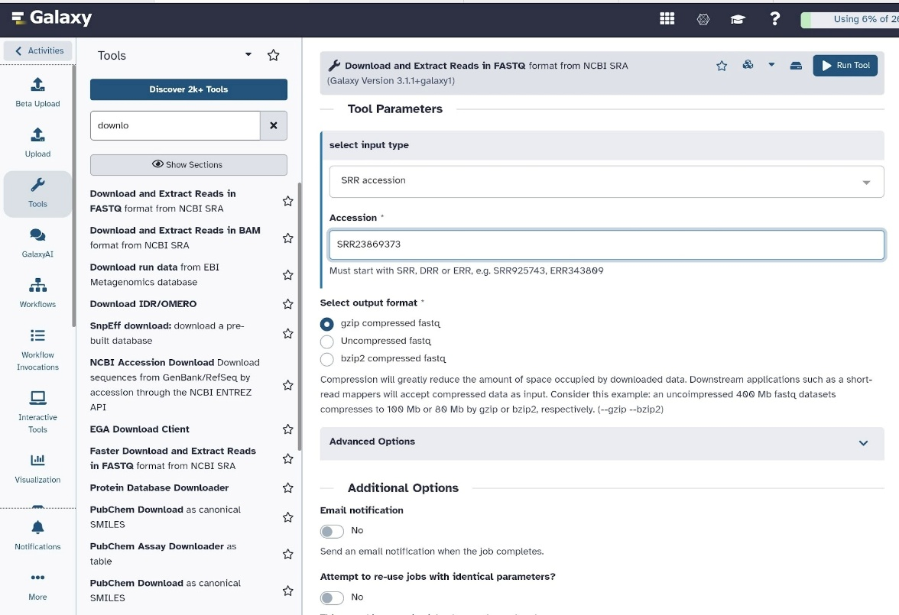
Figure 1. Galaxy interface showing the Download and Extract Reads from NCBI SRA tool with accession SRR23869373 entered
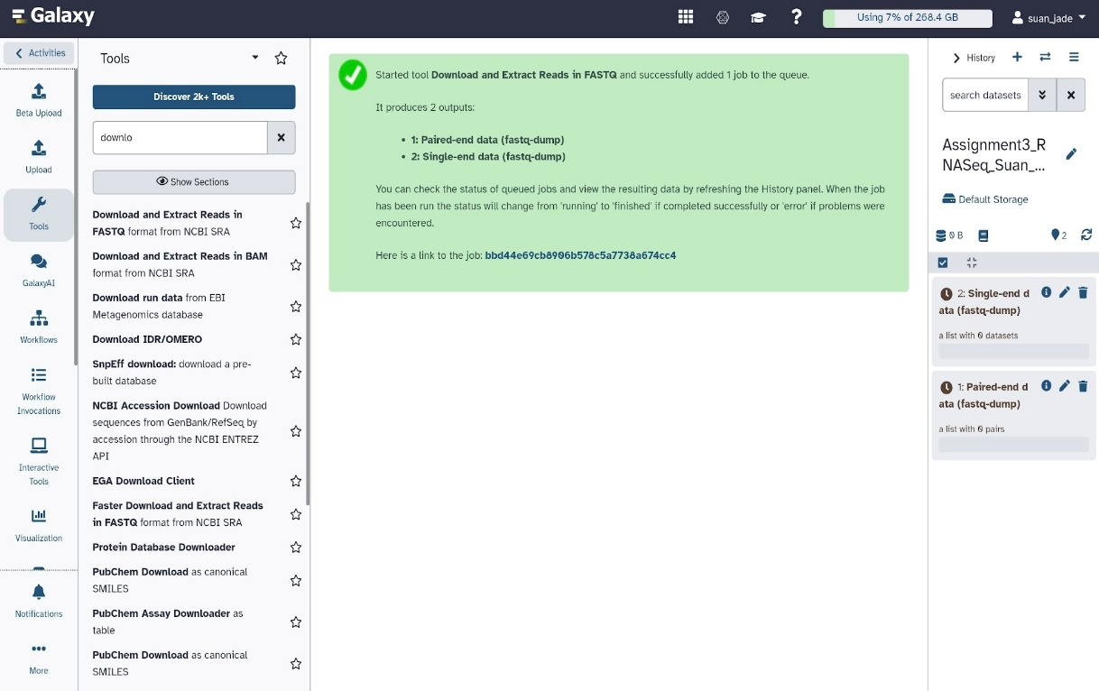
Figure 2. Galaxy job submission confirmation showing successful SRA download job added to queue
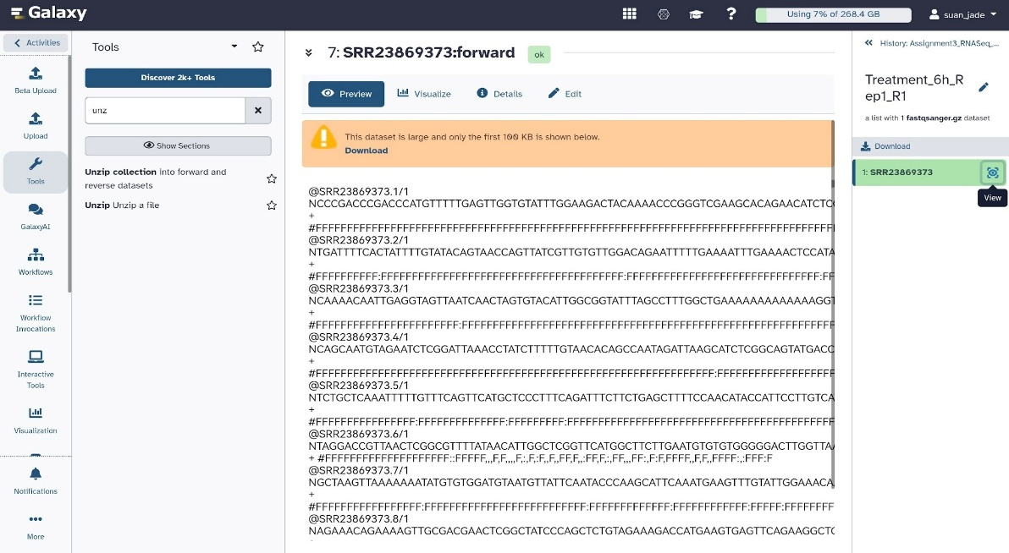
Figure 3. FASTQ file preview for R1 (forward reads) displaying the standard 4-line sequence format
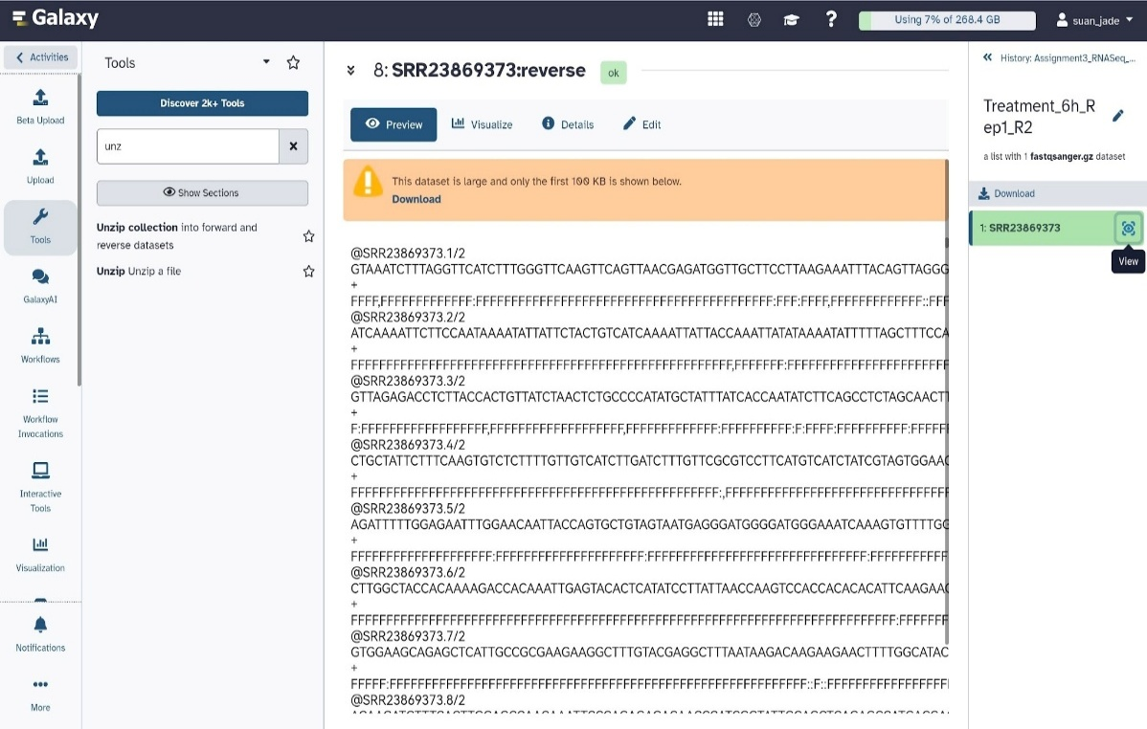
Figure 4. FASTQ file preview for R2 (reverse reads) confirming paired-end data structure

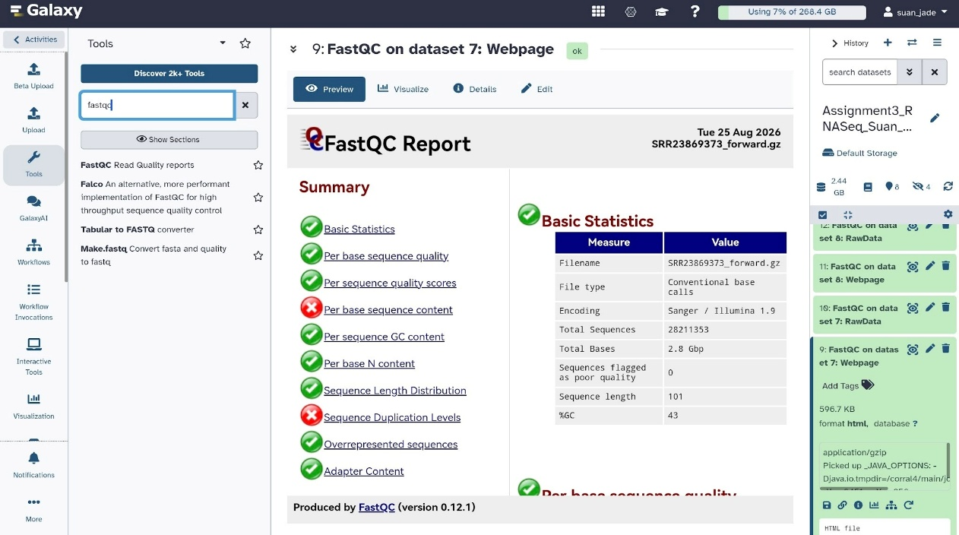
Figure 5. FastQC Basic Statistics summary for R1 — showing total reads (28,211,353), read length (101 bp), and GC content (43%).
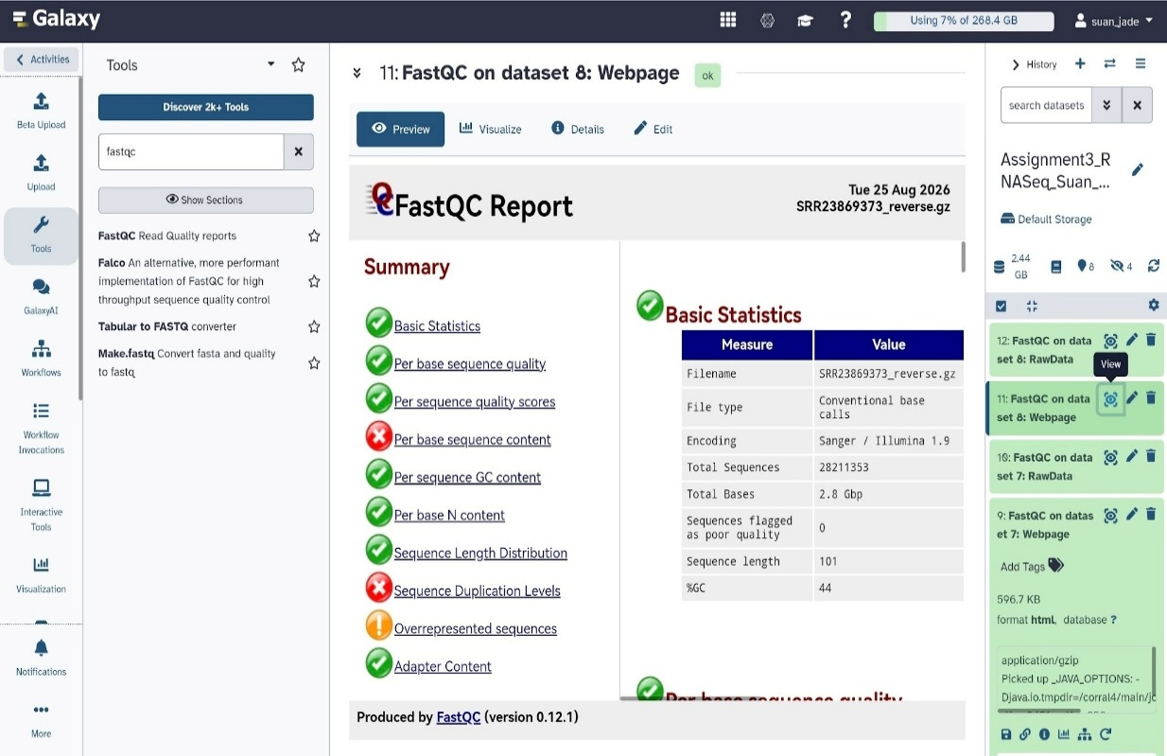
Figure 6. FastQC Basic Statistics summary for R2 – showing reads (28,211,353), read length (101 bp), and GC content (44%)

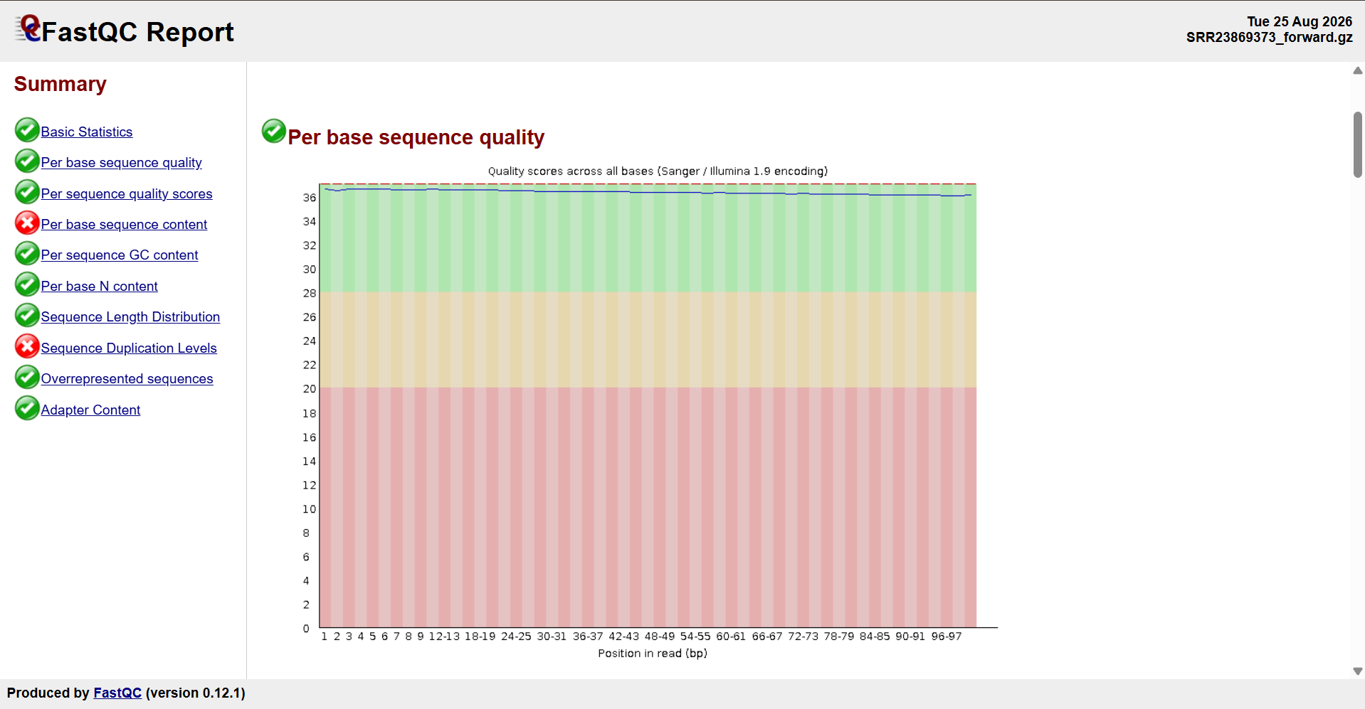
Figure 7. FastQC Per Base Sequence Quality Plot — R1, showing all quality scores in the green region at Q36
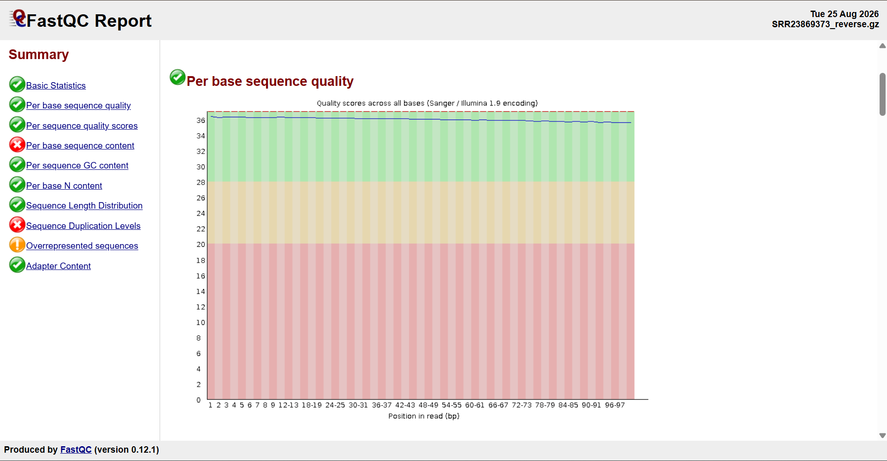
Figure 8. FastQC Per Base Sequence Quality Plot — R2 (Reverse), showing all quality scores in the green region at Q35–36
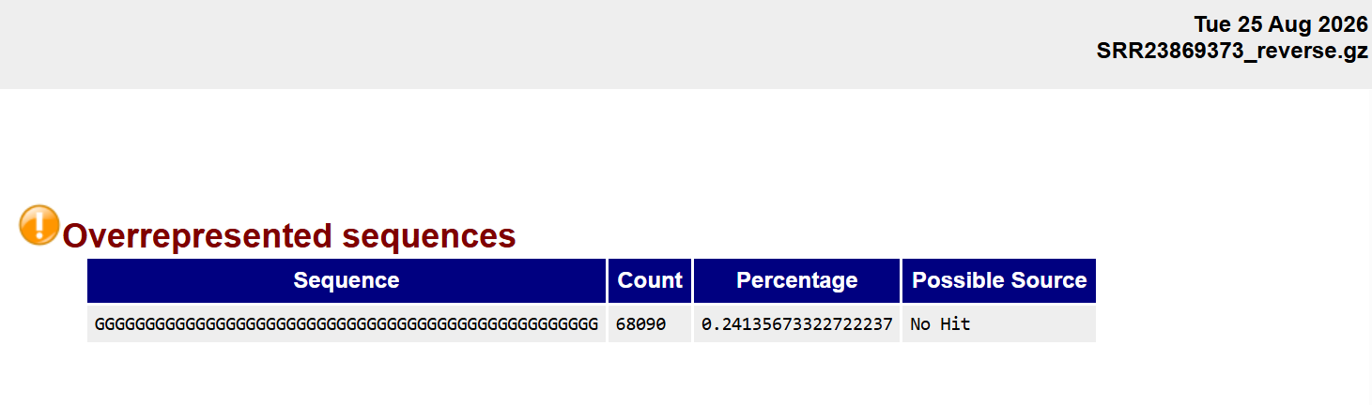
Figure 9. FastQC Overrepresented Sequences — minor poly-G artifact (0.24%) in R2, common Illumina artifact not biological contamination

